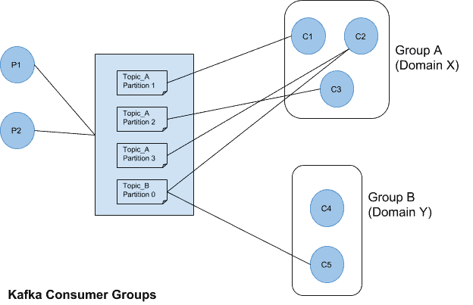

**Scenario 1:**

Here in this case we have 1 kafka producer (publisher) and 2 kafka consumer (subscriber).

And both consumers are of same group as shown in the the above reference block diagram we can see that from consumers from one specific group of consumers can read data from only one specific partition of mentioned kafka topic. And if we have two kafka consumer groups then they can read same partition independently depends on their business case they are independent they can poll partition independently of consumer groups.

So here in scenario 1 we have two consumers of different group thus when I publish records means (when I ran producer code) here I m publishing only 5 records into kafka topic , as soon as I publish reocrds both kafka consumers read that data (subscribed or we can say poll that data independently) so both read the data same (number of counts is same ) at both kafka consumers.

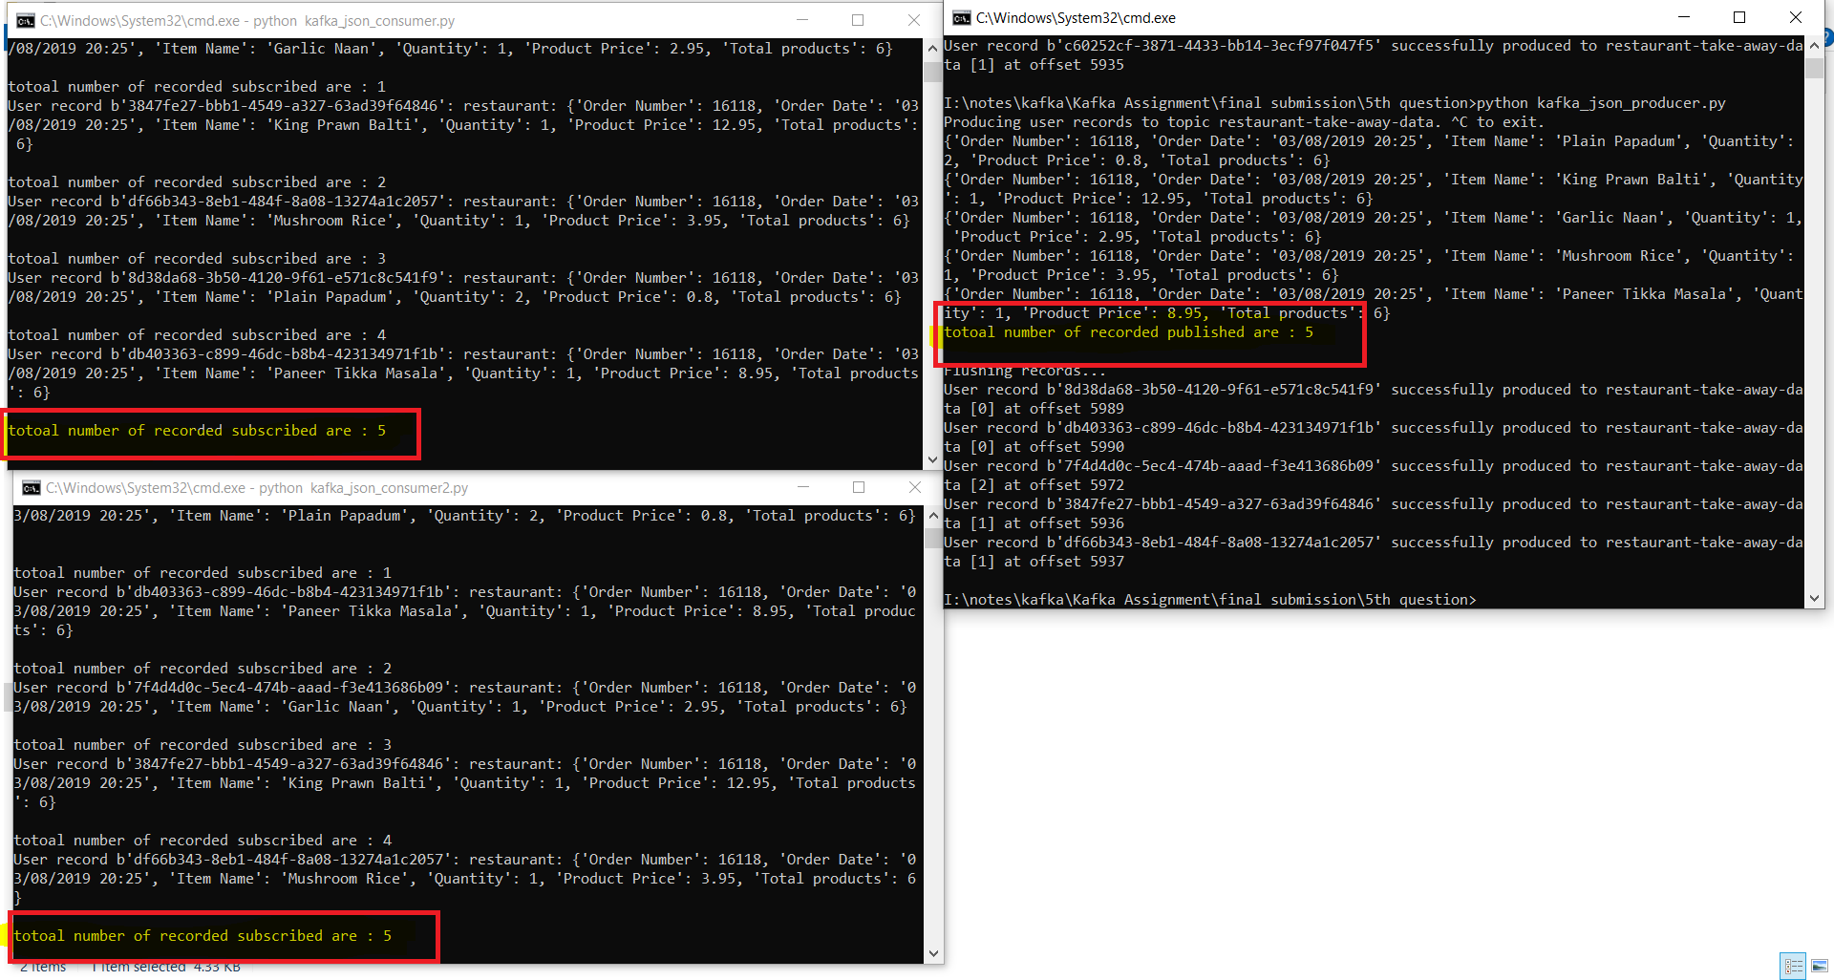

**Scenario 2:**

For the very first time I publish (means I ran producer code) only 5 records (messages) to kafka topic inside partitions so these in screenshot below you can see as both consumer is of same group so at once one kafka consumer can subscribed (means can read data means messages from only on partition of specific same topic) so here only first consumer reads data and second consumer is on waiting has not read any data.

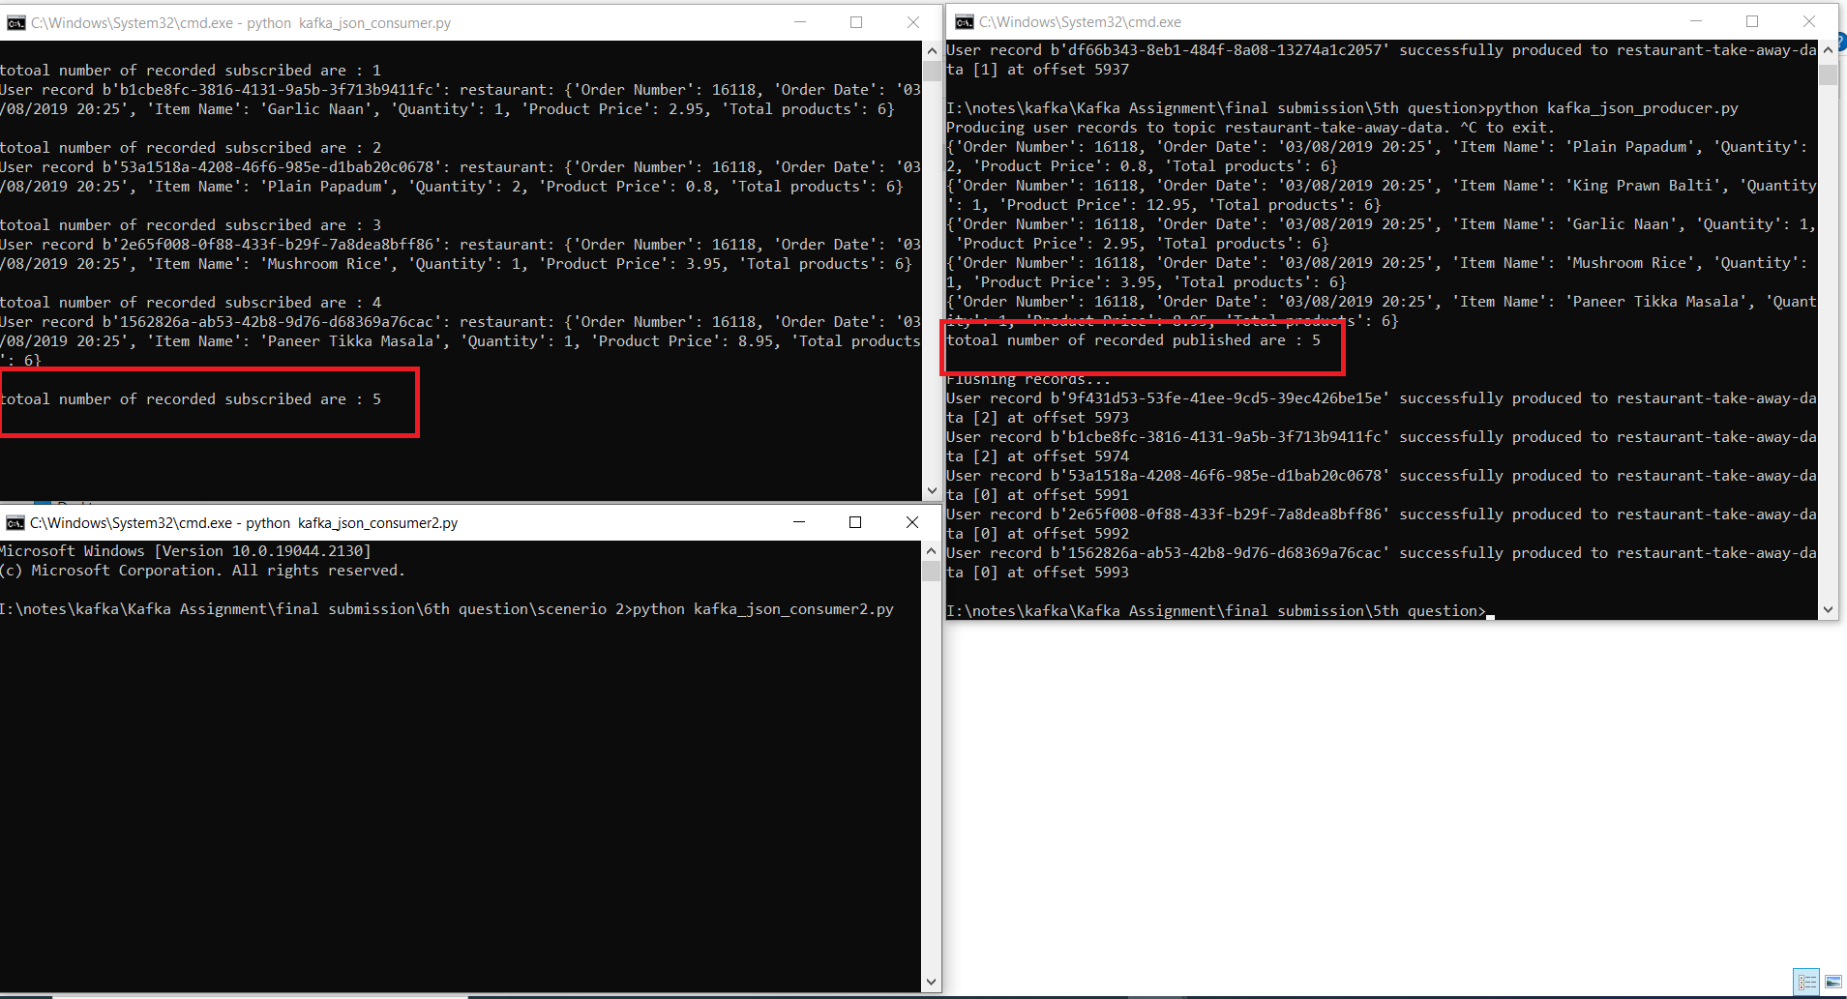

But when I ran producer code again means when I publish more 5 reocrds (total 10 records till now we have publish inside kafka topic into different partitions )that time from below screen shot you can see that 1st kafka consumer has read 1 record from 2nd group of 5 records and 2nd kafka consumer has read 4 reocrds.

